**DOCUMENTATION**

Duy Pham – 47522003

Presentation: https://youtu.be/gPQrar1vt4A

**Task 1. “task1.py”**

1. **Clean text:**

* Tokenize the text and then remove stop words.

* Transform the words into their root form.

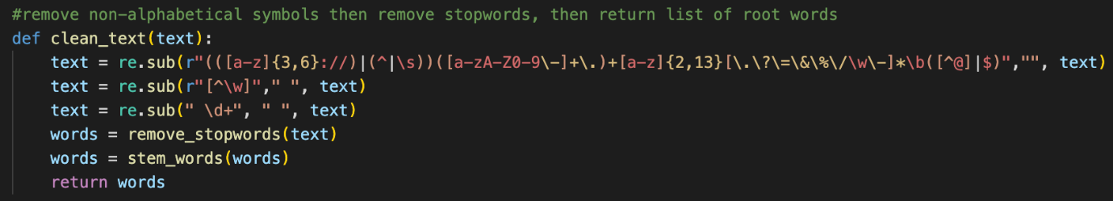

* Clean non-alphabetical characters, URLs, and numbers, remove stop words, transform words into root form and then return the cleaned text.

1. **Extract keywords**

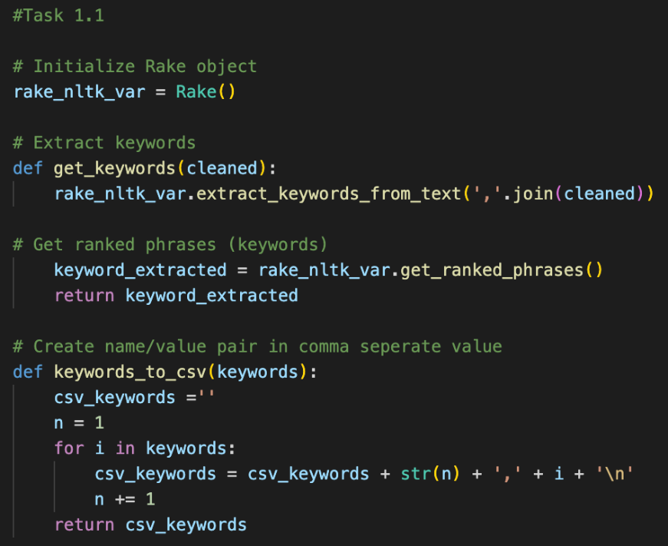

* Use nltk to extract keywords from the text.
* Get the rank list.
* Make name/value pair for each keyword and its ranking.

1. Find the name entity

* Using nltk.pos_tag, check each word’s name entity.
* Return name/value pair for each word and its name entity.

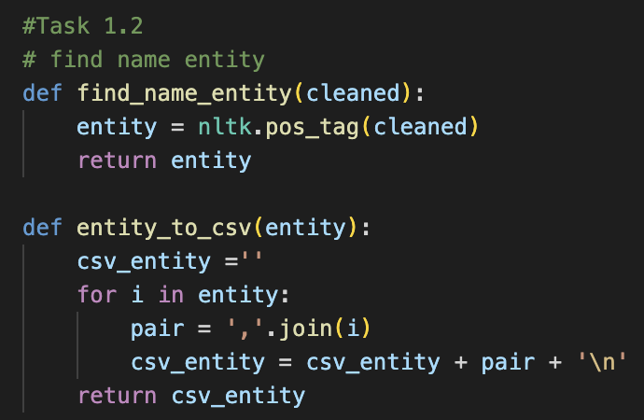

1. **Extract topics**

* Create a gensim dictionary object using the corpus.
* Create a variable in which we store the Bag-of-Words transformed documents.
* Train the model and get the topic list.
* Create name value pair for the topic and the probability.

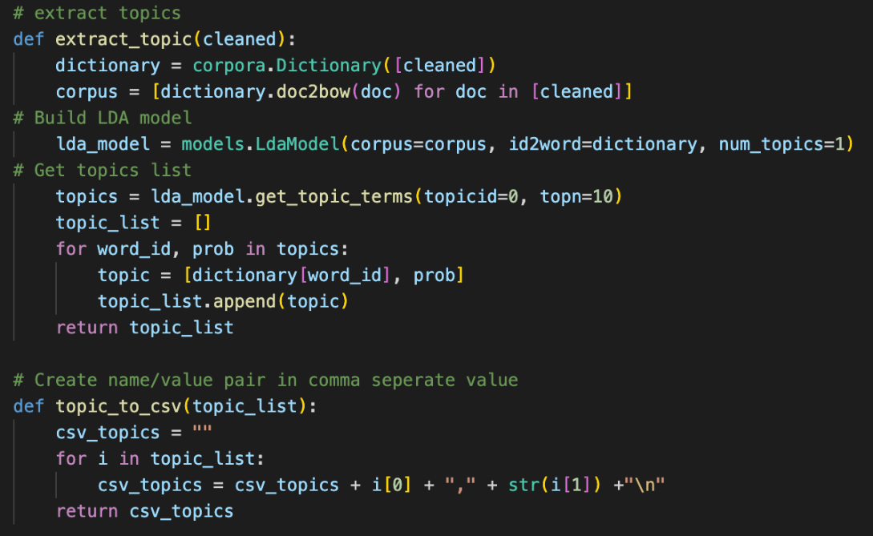

1. **Extract sentimental.**

* Create SentimentIntensityAnalyzer object.
* Get the sentiment of the text, and delete the compound value.
* Get the highest score as the final sentiment of the text.
* Create a name/value pair of the sentiment of the text

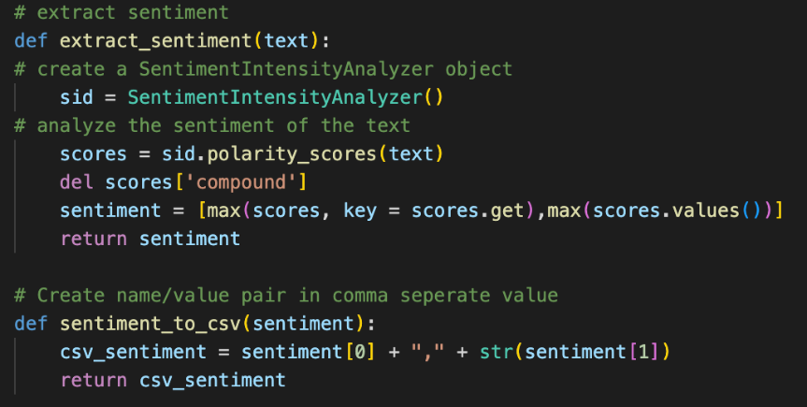

1. **Connect to the tweets dataset and apply all the methods.**

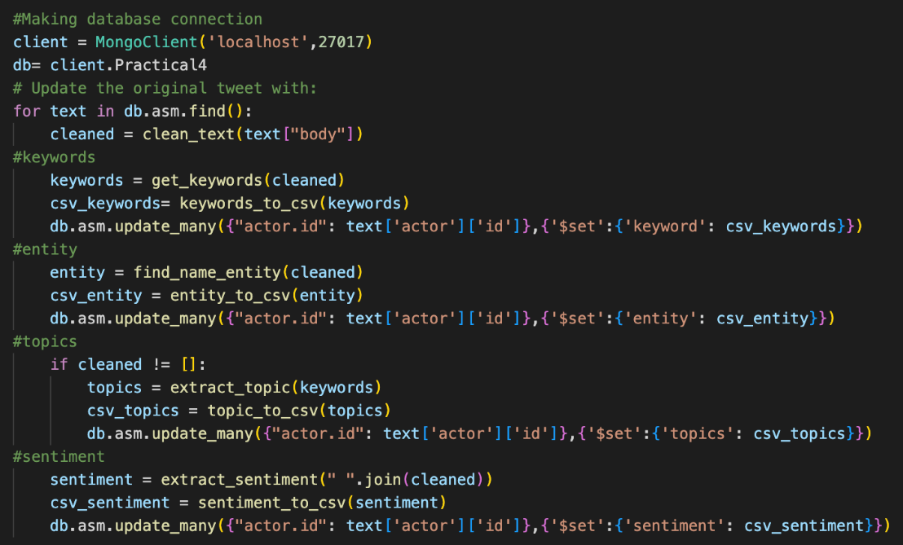

**Extract text. “txt.py”**

* For tasks 2, 3, 4, and 5, we need txt files extracted from the tweets as the input. Therefore, I’ve made an application to extract all the text needed and write it into separate txt files.
* “task2.txt” includes the text of each tweet in a line.

* “task3.txt” extract the city from the tweet’s ‘address’ field. For tweets without location info, it will return “No location info”. For tweets in countries other than Australia, it will return “Other country”. For tweets without city info, it will return “No city info”. For anything else, return the city name.

* “task4.txt” extract the tweet’s id info numbers, and clean all the text and the tweet’s content. Output in comma-separated format.

* “task5.txt” extract the keywords from each text and outputs into a string.

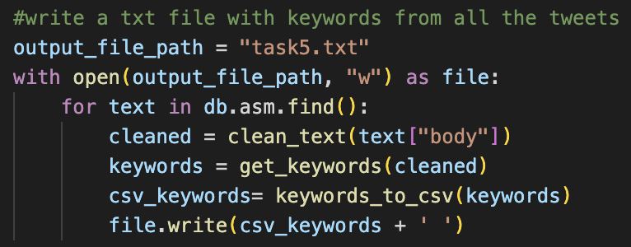

**Task 2. “task2.py”**

* Take input “task2.txt”.
* Split each line into words.
* Map each word with value 1.
* Group the same words and sum up the number.

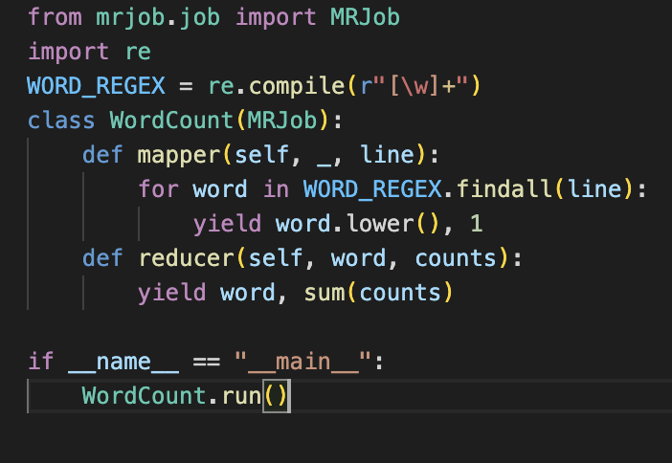

**-Pseudocode:**

Input the txt file

Mapper :

For each word in the line:

Return the word with value = 1

Reducer:

Map all the same words together, sum the value

Flowchart:

**Task3. “task3.py”**

* Take input “task3.txt”.
* Map each line(city) with value 1.
* Group the same cities and sum up the number.

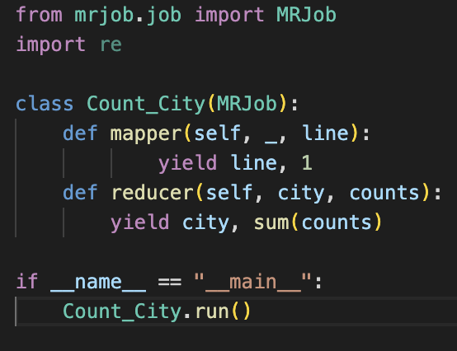

**-Pseudocode:**

Input the txt file

Mapper :

For each line:

Return the line with value = 1

Reducer:

Map all the same line together, sum the value

**Task4. ”task4.py”**

* Take input “task4.txt”.
* Split each line into ID number and the tweet’s content.
* Map ID and text into the same key.
* Sort each key by the ID number.

**-Pseudocode:**

Input the txt file

Mapper :

For each line:

Split into id and text.

Return key with value (id, text).

Reducer:

Map all the line together, sort by ID number

-**Flowchart:**

**“task4_2.py”**

* I’ve used the mergesort algorithm to sort the ID.
* Split the tweets into half until they become single tweets, then iterate sort them in order and merge them into one

For the performance evaluation, I’ve added the running time for each method.

* MapReduce method increased the running speed by a lot, from 0.015 seconds to 7.9*10-6 seconds.

**Task5. “task5.py”**

* For task 5, I’ve used the sklearn library.
* Transforming the text into a matrix of TF-IDF features
* Converting the first row of the TF-IDF matrix into a DataFrame
* Convert the pandas dataframe into DASK dataframe, with n participant = 100 ( split into 100 part to compute )
* Sorting it by descending order of TF-IDF scores and taking n top value ( n is the input number)
* Compute the task

Result:

* Result will be in the CSV file with the “|” separator.
* N top result display with n as an input number
* Below is the sample result of 6 top words:

Limitation:

* DASK is only applied in the sorting step, as I’m using the sklearn library to compute TF-IDF values.

Improvement:

* Perhaps using another method might enable me to find other steps to parallelize.